**VOC Summarization**

An AI tool designed to summarize and query video content from a Voice of Customer (VOC) database, named Enjoy HQ. The tool will feature a user-friendly interface allowing product owners, new product development teams, quality control teams, and continuous improvement teams to request video summaries based on transcripts. It will enable users to specify summary length and focus on specific themes.

The product aims to be broadly available to all internal Fluke users requiring the functionality. It should provide timely, adjustable, and customizable summaries with options to export results as PDF documents or PowerPoint presentations. Additionally, the tool will include usage tracking to monitor adoption and application, with success measured by user engagement and satisfaction.

**Architecture Diagram:**

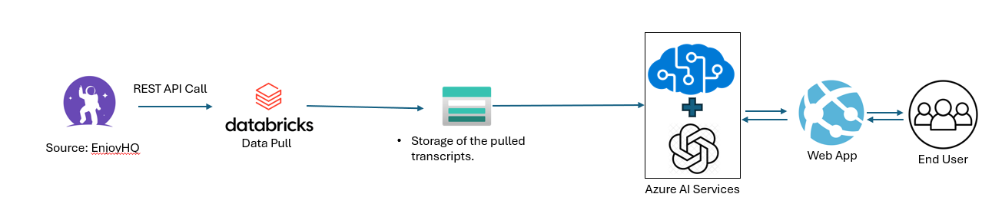

|  |  |
| --- | --- |
| Azure Databricks script URL | https://adb-1943773873358740.0.azuredatabricks.net/?o=1943773873358740#notebook/3129209821746893/command/3129209821746894 |
| Azure Data factory pipeline URL | <https://adf.azure.com/en/authoring/pipeline/Fluke_VOC_summarization?factory=%2Fsubscriptions%2F52a1d076-bbbf-422a-9bf7-95d61247be4b%2FresourceGroups%2Fflkubi-dev-rg-001%2Fproviders%2FMicrosoft.DataFactory%2Ffactories%2Fflkubi-adf-dev> |
| Trigger Name | Trigger_VOC_summarization |
| Azure Resource Group Name | flk-dreamvoc-prd |
| Code link | https://github.com/microsoft/sample-app-aoai-chatGPT |
| Application URL | https://voc-transcript-prod.azurewebsites.net/ |

1. **List of Azure resource group created:**
2. Web app service - voc-transcript-prod
3. Cognitive Search service - voc-prod-searchservice
   1. Indexer - vocprodtranscriptionindex
   2. Index - transcriptionindexer
   3. Data source - transcription
4. Azure Blob storage - vocblobstorageaccount
5. Open AI Service - voc-prodopenai-service
6. **Data Injection:**
7. Python script in Databricks will be executed twice daily and transcript files are copied into Azure Blob storage.

**Storage Location:** ingestionpoc/Source-Conversations/EnjHQ/staging/

1. Cognitive search indexer will be executed, and data is indexed in the index on schedule basis.

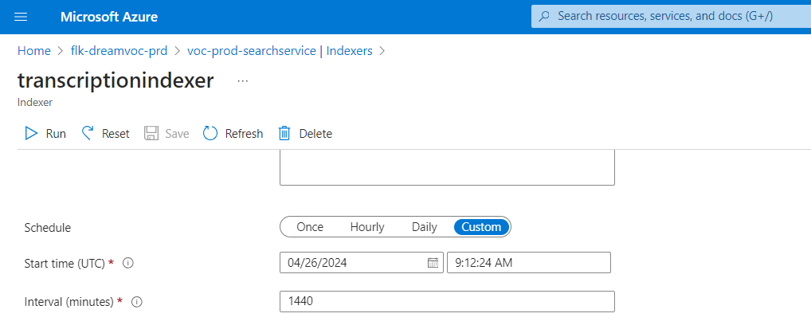

User responses and chat history are stored in Azure cosmos DB

Cosmos DB account name : **flk-voc-cosmosdb-prod**

Container name : **db_conversation_history**

Table name : **conversations**

**Power BI report :**

<https://app.powerbi.com/groups/6fec84af-8245-4738-b317-f29326432ae3/reports/52bf3ce4-a208-4ac0-8ba6-53fba6a170b9?ctid=0f634ac3-b39f-41a6-83ba-8f107876c692&pbi_source=linkShare>

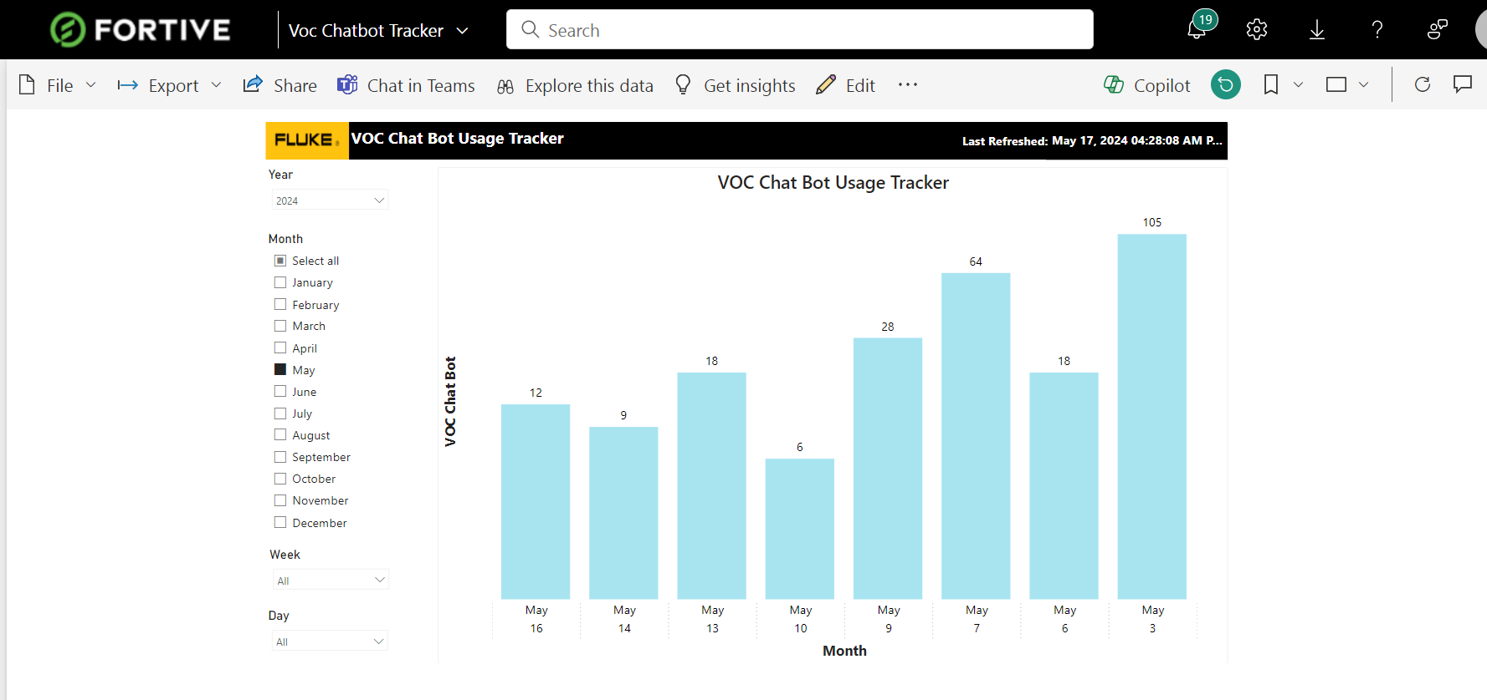

|  |  |
| --- | --- |
| New Features | Remarks |
| Dynamic summarization and thematic expressions | By default, Microsoft code handles this feature |
| Building ML pipeline | Completed, details mentioned in the above section |
| Scalability and Performance | Configurations made in App server |
| User friendly interface for video summarize | By default, Microsoft code handles this feature |
| Non-Verbal cue detection | Not feasible |
| Complex query capability | By default, Microsoft code handles this feature |
| Export summary content | Changes made in front end to download the summarize |
| Azure compatibility and GPT-4 integration | By default, use case is implemented with GPT-4 model |
| Usage tracking and Analytics | Power BI report has been created |
| GDPR compliance and Data privacy | Azure supports the GDPR and Data privacy |
| System documentation and User support | System document created with resource details |
| Quality Assurance and testing | Executed and completed unit testing for features added |